**Chapter3 System model**

In order to improve traffic efficiency and safety and to assist drivers to reduce the traffic accident and energy consumption, therefore, it is an efficient method that selecting relay transmits information to more vehicles in the transmission of one transmitter in V2X transmission. In this way, vehicles in the transmission range of the transmitter should listen to the multiple transmitted package concurrently. This communication process is a kind of twice hopping network where multiple receivers try to receive the same packet from one transmitter through selecting relay vehicles. In this part, we describe the models utilized in this work.

**3.1 Environment model**

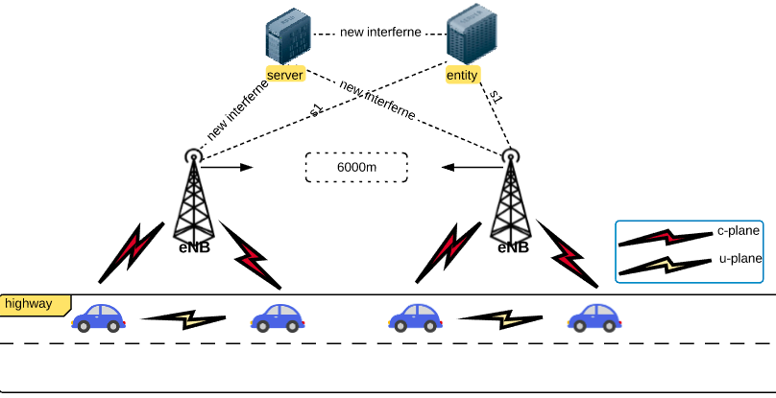

Figure.1 System Architecture

C-ITS can address the increasing problems of congestion, safety and environment. So it requires V2X communication working efficiently in any environment, such as urban, rural or highway scenario. In this research, under highway scenario is considered to detect the system performance of V2X communication.

As shown in Figure.1, network assisted direct V2X transmission model under highway scenario is implemented for packet transmission. All vehicles are connected to the operator in the C-plane. Meanwhile, in the U-plane transmitter can directly communicate with the receivers in the proximity of itself. In order to provide network-assisted direct V2X communication, a traffic-related and safety-related server has been assumed in the system architecture, which is embedded in the core network. It can support location information exchange with another mobility management entity which regularly collect the location information from vehicles. According to the collecting context information, this server can allocate radio resources efficiently for the direct V2X communication.

And the highway has 3 lanes. In this model, a 20-kilometer highway is used for simulation. According the requirement, we assume the width of this highway is 20 meter. It is assumed that the coverage of each base station is 6000m.

|  |  |  |
| --- | --- | --- |
| Scenario: highway | | |
| Key parameter | value | unit |
| Length of highway | L=20 | km |
| Width of highway | W=20 | m |
| Inter-vehicle spacing | Ls=10 | m |
| Lane of highway | La=3 |  |
| Range of base station | db=6 | km |
| Height of the antenna of base station | Hbs=1.5 | m |
| Height of the antenna of mobile station | Hus=1.5 | m |
| Transmission range of vehicle | Range=100 | m |

Table.1: Main parameters

**3.2 Deployment model**

As Table.1 shows, the distance between two vehicles is 10 meter. So the deployment of vehicles on the highway is 100 vehicles per lane per kilometers.

$$UE=100×lane×db$$

So the number of vehicles under one base station is 1800. In 3GPP, a direct V2X communication over side link can be used to facilitate this information exchange procedure [3GPP document, TS 23.303, *Proximity-based services (ProSe); Stage 2*, June 2017. ].In order to achieve the CPE and enable the fully automated driving in highway, a communication range of 1000 meters is required.

And an isotropic and 1.5-meter antenna is installed on each vehicle. Also each base station is installed the same antenna. we do not consider any movement of vehicles in order not to add any additional effects which have not been considered in the analysis.

**3.3 Radio propagation channel model**

The hata model is a radio propagation model for predicting the path loss of mobile transmissions in exterior environments. The model is suited for both point-to-point and broadcast communications.

$$C_{H}=0.8+\left(1.1\log_{10}f-0.7\right)h_{M}-1.56\log_{10}f$$

where

$C_{H}$ =Antenna height correction factor.

$f$ =carrier frequency.

Unit: Megahertz(MHz)

$h_{M}$ =height of mobile station antenna.

Unit: meter(m)

Hata model describes the path between transmitter(Tx) and receiver(Rx). The distance between transmitter and receiver is considered as parameter to measure received power.

$$PL=69.55+26.16\log_{10}f-13.82\log_{10}h_{B}-C_{H}+[44.9-6.55\log_{10}h_{B}]\log_{10}d$$

$PL$: path loss in areas.

Unit: decibel(dB)

$h_{B}$: height of base station antenna.

Unit: meter(m)

$d$: distance between the transmitter and receiver.

Unit: kilometer(km).

**3.3.1 physical layer**

|  |  |  |
| --- | --- | --- |
| Channel model: Hata model | | |
| Key parameter | value | unit |
| Transmitter power | 24 | dBm |
| Transmitter antenna gain | 0 | dBi |
| Receiver antenna gain | 3 | dBi |
| Carrier frequency | 2 | GHz |
| Operational bandwidth | 10 | MHz |
| Package size | 212 | Byte |
| Noise figure of mobile station | 7 | dB |
| Thermal noise level | -174 | dBm/Hz |

Table.2: channel model

As Table.2 shows:

**Maximum Transmit Power:** Each vehicle transmits packages with a constant allowed transmitting power of 24 dBm. In this work, V2X communication utilize a carrier frequency of 2 GHz as frequency of transmission.

**Frequency band:**

* One 10 MHZ frequency band for one-hop for efficiency-related and safety-related applications in V2X communication system.
* Two 10 MHZ frequency bands for two-hop communication for efficiency-related and safety-related applications in V2X communication system.
* One 10 MHz frequency band for two-hop communication for efficiency-related and safety-related applications in V2X communication system.

**3.3.2 Antenna:**

The effective of V2X applications require low latency and high reliability. So a stable radio link is the necessary condition to obtain high reliability. There are some differences between cellular network and V2X communication. In cellular communications the base station is at an elevated position and has a sectored coverage around it. But in V2X communication, both transmitter and receiver antennas are at the same 1.5-meter height relatively close to the ground level. Moreover, we assume the transmitter antenna gain is 0 dBi, and the receiver antenna gain is 3dBi in this communication system.

**3.4 Traffic model**

Traffic model specific for safety-related issue in V2X communication includes both periodic and event-driven package transmission.

**Event-driven package transmission:** For this transmission, once a vehicle experiences certain events from local environment. The event-driven messages will be delivered to all the vehicles in the proximity. However, the frequency of generating messages is much lower.

**Periodic transmission:** Compared to event-driven package transmission for V2X communication, the periodic transmission is more reliable by continuously transmitting information including location, speed or roadway situation. We utilize a periodic package transmission of 212 Bytes with 10 HZ periodicity for each vehicle.

**3.5 Modulation and coding scheme**

An appropriate modulation and coding scheme (MCS) is very important for transmission every time. Because of near-far effect, the links between transmitter and receivers in its proximity can experience varied channel states.

At the same time, it is a hard work to collect the real time channel state information(CSI) for at the transmitter side under highway scenario. So it’s vital to adapt to an appropriate MCS with a more robust link performance in case of links experiencing worse channel states. [ Lianghai J, Liu M, Weinand A, et al. Direct vehicle-to-vehicle communication with infrastructure assistance in 5G network[C]//Ad Hoc Networking Workshop (Med-Hoc-Net), 2017 16th Annual Mediterranean. IEEE, 2017: 1-5.]

A more robust transmission means that a lower MCS is required. However, a lower MCS means that more frequency and time resources are required to transmit the same size package. Therefore, the MCS is controlled by central service for each transmission based on real time system load.

In this work,

$$datavolume=packetsize×UE×8×period÷{10}^{6}$$

$$efficiency=datavolume÷bw$$

$datavolume$: the data volume.

Unit: Mbps

$efficience$: transmission spectral efficiency.

Unit: bits/Hz

$packetsize:$ the packet size.

Unit: Byte

UE: the number of mobile station.

$period$: the frequency of periodic transmission.

Unit: Hz

$bw$: the transmission bandwidth.

Unit: MHz

According to the calculation, we can decide the MCS efficiency according to the number of mobile stations, bandwidth and required size of packets. Decided efficiency to make sure these parameters such as how many users can be supported by using these transmission resources. In order to make sure resource that is enough. The same size of users, if the BW is not enough, then we need to use much larger MCS efficiency to transmit the same packet. Meanwhile, the larger MCS means lower robust. if the number of user is small, then each user can be allocated more time and frequency resources to transmit more packets. Because of the limitation of MSC and bandwidth, the number of user for is also limited in V2X communication system.

When we get the efficiency value, we should select the appropriate value according to the table.3. the value selected should be equal to or just greater than the calculated efficiency. If the selected MCS is smaller than the one we calculated, then the system is overload and some users cannot get the resource and fail to transmit.

|  |  |  |
| --- | --- | --- |
| CQI | Modulation | Spectral Efficiency |
| 0 | Out of range | |
| 1 | QPSK | 0.1523 |
| 2 | 0.2344 |
| 3 | 0.3770 |
| 4 | 0.6016 |
| 5 | 0.8770 |
| 6 | 1.1758 |
| 7 | 16 QAM | 1.4766 |
| 8 | 1.9141 |
| 9 | 2.4063 |
| 10 | 64 QAM | 2.7305 |
| 11 | 3.3223 |
| 12 | 3.9023 |
| 13 | 4.5234 |
| 14 | 5.1152 |
| 15 | 5.5547 |

Table.3 CQI-MCS mapping table

**2.6 Thermal Noise model**

Noise power in a receiver is usually dominated by thermal noise. Thermal noise (Nyquist noise) is the electronic noise generated by the thermal agitation of the change carriers inside of electrical conductor at equilibrium spectrum, which happens regardless of any applied voltage. Thermal noise level is -174 dBm/Hz for highway scenario.

$$P_{dBm}=-174+10\log_{10}bw+NF$$

$P_{dBm}$: Power of noise

Unit: dBm

$bw$: the receiver bandwidth

Unit: Hz

$NF$: the noise figure of receiver

Unit: dB